Manual

Computational Anatomy Toolbox - CAT12


Quick start guide 3
Introduction and Overview 5
Getting Started 5
Download and Installation 5
Starting the Toolbox 6
Basic VBM analysis (overview) 6
Basic VBM Analysis (detailed description) 9
Preprocessing Data 9
First Module: Segment Data 9
Second Module: Display one slice for all images 11
Third Module: Check sample homogeneity 11
Fourth Module: Smooth 13
Fifth Module: Estimate Total Intracranial Volume (TIV) 13
Building the Statistical Model 14
Two-sample T-Test 15
Full Factorial Model (for a 2x2 Anova) 16
Multiple Regression (Linear) 17
Multiple Regression (Polynomial) 18
Full Factorial Model (Interaction) 19
Full Factorial Model (Polynomial Interaction) 20
Estimating the Statistical Model 21
Checking for Design Orthogonality 21
Defining Contrasts 24
Special Cases 28
CAT12 for longitudinal data 28
Change Settings for Preprocessing 29
Preprocessing of Longitudinal Data 29
Statistical Analysis of Longitudinal Data in One Group 30
Statistical Analysis of Longitudinal Data in Two Groups 31
Altered Workflows for VBM-analyses 35
Adapting the workflows 36
Customized Tissue Probability Maps 36
Customized DARTEL-template 37
Other variants of computational morphometry 39
Deformation-based morphometry (DBM) 39
Surface-based morphometry (SBM) 40
Region of interest (ROI) analysis 43
Additional information on native, normalized and modulated volumes 45
Naming convention of output files 47
Calling CAT from the UNIX command line 49
Technical information 49

Quick start guide
Errors during preprocessing
Please use the Report Error function if any errors during preprocessing occurred. You have to first select the "err" directory that can be found in the folder of the failed data set and finally the indicated zip-file in the mail should be attached manually.

VBM data
- Segment data using defaults (for longitudinal data use longitudinal pipeline)
- Check data quality using sample homogeneity for VBM data
- Smooth data (suggested starting value 8mm)
- Estimate total intracranial volume (TIV) in order to correct for different head size and volume
- Build 2nd-level model:
  - Use "Full factorial" for cross-sectional data
  - Use "Flexible factorial" for longitudinal data
  - Use TIV as covariate (confound) to correct for different brain sizes and select centering with overall mean
  - Select threshold masking with an absolute value of 0.1. This threshold can be increased in the final analysis to 0.2 or even 0.25.
- Estimate model
- Check design orthogonality using the “Review” function in the SPM GUI. If you find a considerable correlation between TIV and any other parameter of interest it is recommended to rather use global scaling with TIV. Check the section “Build the statistical model” for more details
- Optionally transform and threshold SPM-maps to (log-scaled) p-maps or correlation maps
- Optionally estimate results for ROI analysis using “Analyze ROIs”. Here, the SPM.mat file of an already estimated statistical design will be used. Please check the online help “Atlas creation and ROI based analysis” for more information.

Additional surface data
- Segment data and additionally select "Surface and thickness estimation" in "Writing options"
- Optionally extract additional surface parameters (e.g. suclus depth, gyrification index, cortical complexity)
- Resample and smooth surface data (suggested starting value 15mm for cortical thickness and 20mm for folding measures)
- Check data quality using sample homogeneity for surface data
- Build 2nd-level model: Use "Full factorial" for cross-sectional data and "Flexible factorial" for longitudinal data
- Estimate surface model for each hemisphere
- Optionally Display surface results for both hemispheres. Select results (preferably saved as log-p maps using “Transform and threshold SPM-surfaces”) for left and right hemisphere in order to show render views of your results
- Optionally Extract ROI-based Surface Values such as thickness, gyrification or fractal dimension to provide ROI analysis.
- Optionally estimate results for ROI analysis using “Analyze ROIs”. Here, the SPM.mat file of an already estimated statistical design will be used. Please check the online help “Atlas creation and ROI based analysis” for more information.

Introduction and Overview

This manual is intended to help any user to perform a computational anatomy analysis using the CAT12 Toolbox. Although it will mainly focus on voxel-based morphometry (VBM) other variants of computational analysis such as deformation-based morphometry (DBM), surface-based morphometry (SBM), and region of interest (ROI) morphometric analysis will be also introduced and can be applied with a few changes.

Basically the manual may be divided into four main sections:
- Naturally, a quick guide of how to get started is given at the beginning. This section provides information how to download and install the software and start the Toolbox. Furthermore, a short overview on the steps of a VBM analysis is given.

- A detailed description of a basic VBM analysis is subsequently given, which will guide the user step by step through the whole process – from preprocessing to the selection of contrasts. This description should provide all necessary information to analyze most studies successfully.

- There are a few special cases of VBM analyses, for which the basic analysis workflow has to be adapted. These cases are longitudinal studies and studies in children or special patient populations. Relevant changes to a basic VBM analysis are described here and a description of how to apply these changes is provided. Importantly, only the changes are described – steps like for example quality control or smoothing are the same as in the basic analysis and not described a second time.

- The manual closes with information on native, normalized and modulated volumes, which determines how the results may be interpreted. Furthermore an overview of the naming conventions used as well as technical information is given.

Getting Started

Download and Installation
- The CAT12 Toolbox runs within SPM12. That is, SPM12 needs to be installed and added to your Matlab search path before the CAT12 Toolbox can be installed (see http://www.fil.ion.ucl.ac.uk/spm/ and http://en.wikibooks.org/wiki/SPM).
- Download (http://dbm.neuro.uni-jena.de/cat12/) and unzip the CAT12 Toolbox. You will get a folder named “cat12”, which contains various matlab files and compiled scripts. Copy the folder “cat12” into the SPM12 “toolbox” folder.

Starting the Toolbox
- Start Matlab
- Start SPM12 (i.e., type “spm fmri”)
- Select “cat12” from the SPM menu (see Figure 1). You will find the drop-down menu between the “Display” and the “Help” button (you can also call the Toolbox directly by typing “cat12” on the Matlab command line). This will open the CAT12 Toolbox as additional window (Fig. 2).

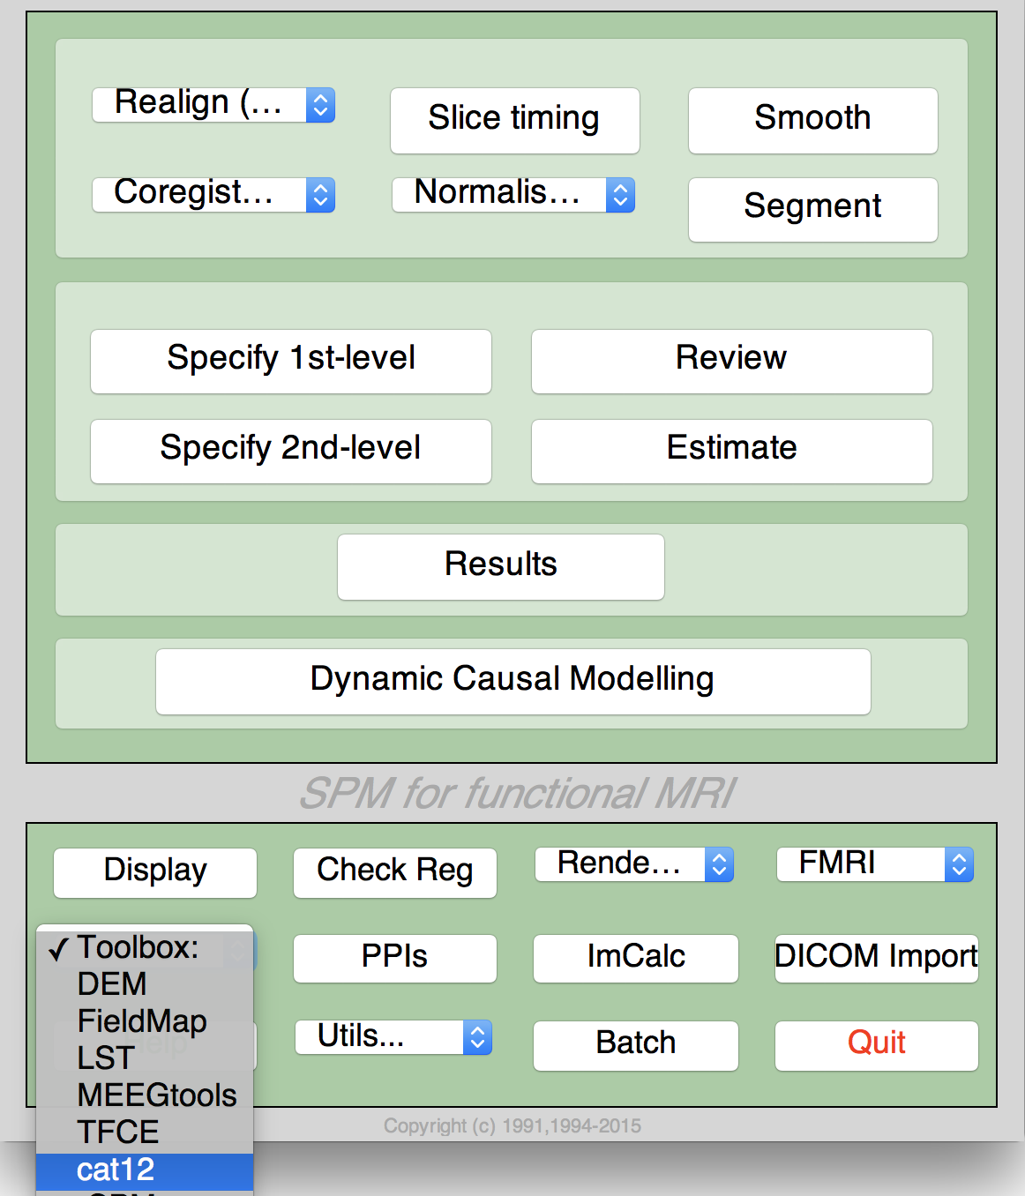 | 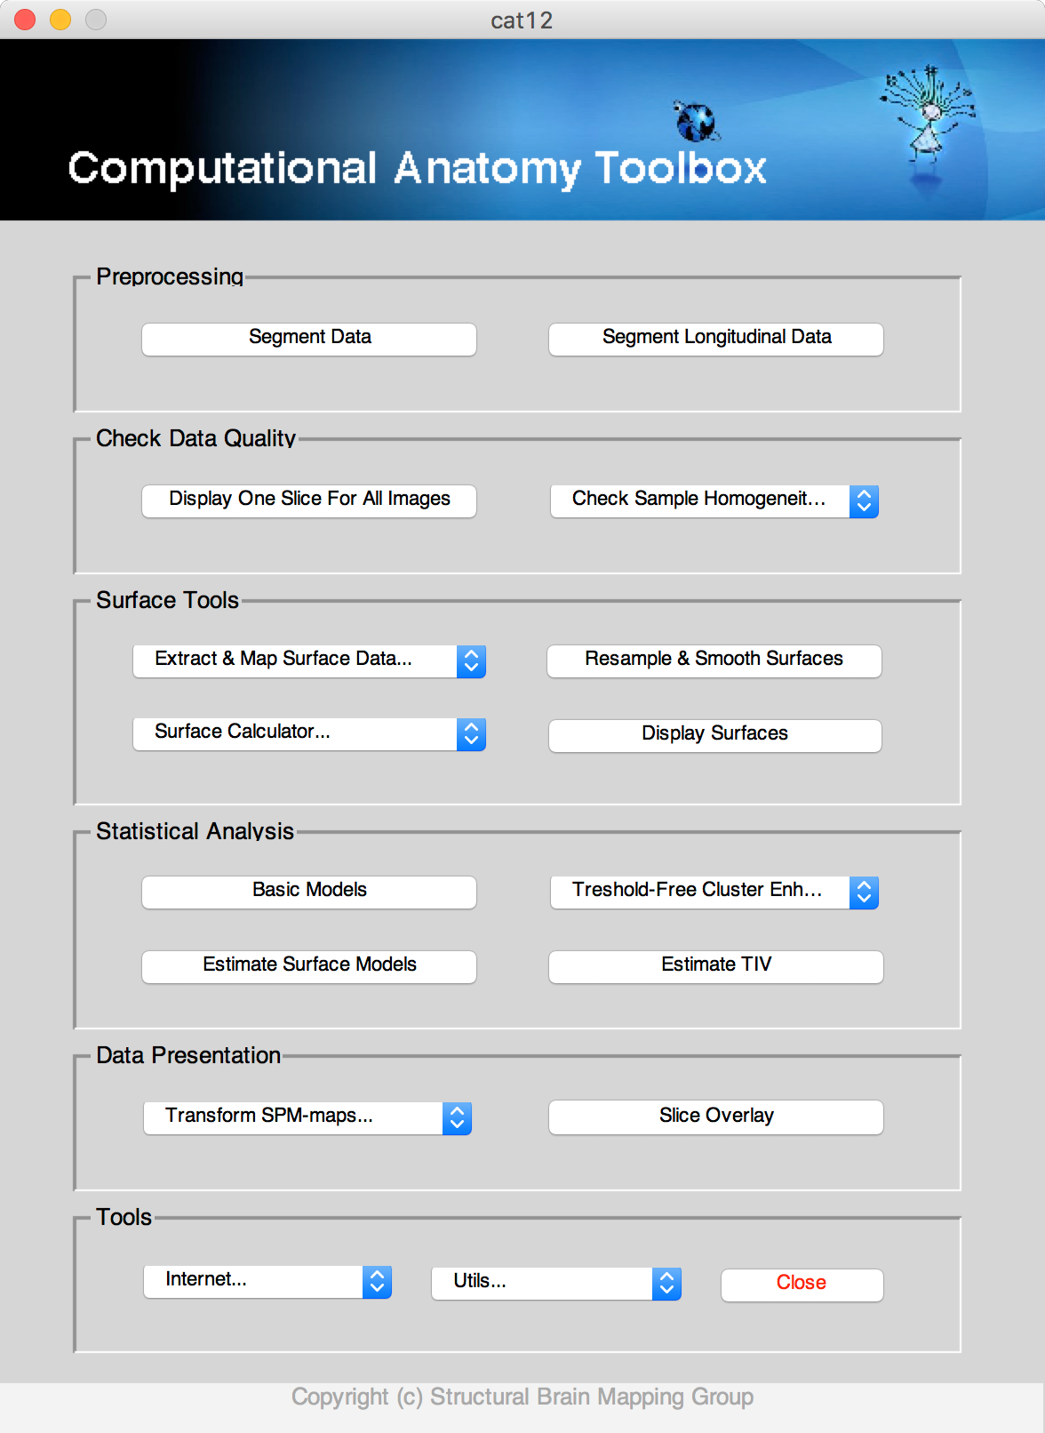
Figure 1: SPM menu | Figure 2: CAT12 Window

Basic VBM analysis (overview)
The CAT12 Toolbox comes with different modules, which may be used for an analysis. Usually, a VBM analysis comprises the following steps

(a) Preprocessing:
- T1 images are normalized to a template space and segmented into gray matter (GM), white matter (WM) and cerebrospinal fluid (CSF). The preprocessing parameters can be adjusted via the module “Segment Data”.
- After the preprocessing is finished, a quality check is highly recommended. This can be achieved via the modules “Display one slice for all images” and “Check sample homogeneity”. Both options are located in the CAT12 window under “Check Data Quality”. Furthermore, quality parameters are estimated and saved in xml-files for each data set during preprocessing. These quality parameters are also printed on the report PDF-page and can be additionally used in the module “Check sample homogeneity”.
- Before entering the GM images into a statistical model, image data need to be smoothed. Of note, this step is not implemented into the CAT12 Toolbox but achieved via the standard SPM module “Smooth”.

(b) Statistical analysis:
- The smoothed GM images are entered into a statistical analysis. This requires building a statistical model (e.g., T-Tests, ANOVAs, multiple regressions). This is done by the standard SPM modules “Specify 2nd Level” or “Basic Models” in the CAT12 window covering the same function.
- The statistical model is estimated. This is done by the standard SPM module “Estimate” (except for surface-based data where the function “Estimate Surface Models” should be used instead.
- If you have used total intracranial volume (TIV) as confound in your model to correct for different brain sizes it is necessary to check whether TIV reveals a considerable correlation with any other parameter of interest and rather use global scaling as alternative approach.
- After estimating the statistical model, contrasts will be defined to get the results of the analysis. This is done by the standard SPM module “Results”.

The sequence of “preprocessing → quality check → smoothing → statistical analysis” remains the same for every VBM analysis, even when different steps are adapted (see “special cases”).

A few words about the Batch Editor…
- As soon as you select a module from the CAT12 Toolbox menu, a new window (the Batch Editor) will open. The Batch Editor is the environment where you will set up your analysis (see Figure 3). For example, an “<-X” indicates where you need to select files (e.g., your image files, the template, etc.). Other parameters have either default settings (which can be modified) or require input (e.g., choosing between different options, providing text or numeric values, etc.).
- Once all missing parameters are set, a green arrow will appear on the top of the window (the current snapshots in Figure 3 show the arrow still in gray). Click this arrow to run the module or select “File → Run Batch”. It is very useful to save the settings before you run the batch (click on the disk symbol or select “File → Save Batch”).
- Of note, you can always find helpful information and parameter-specific explanations at the bottom of the Batch Editor window.
- All settings can be saved either as .mat file or as .m script file and reloaded for later use. The .m script file has the advantage to be editable with a text editor.

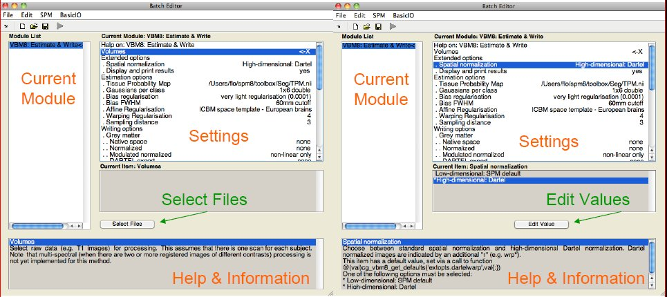
Figure 3: The Batch Editor is the environment where the analysis is set up. Left: For all settings marked with “<-X”, files have to be selected (“Select Files”). Right: Parameters can be edited and adapted (“Edit Value”).

Basic VBM Analysis (detailed description)

Preprocessing Data

First Module: Segment Data

Please note that additional parameters for expert users will be displayed in the GUI if you set the option cat.extopts.expertgui to “1” in cat_defaults.m or call cat12 by:
cat12(‘expert’)

CAT12 → Preprocessing → Segment Data

Parameters:
  - Volumes <-X → Select Files → [select the new files] → Done
    - Select one volume for each subject. As the Toolbox does not support multispectral data (i.e., different imaging methods for the same brain, such as T1-, T2-, diffusion-weighted or CT images), it is recommended to choose a T1-weighted image.
    - Importantly, the images need to be in the same orientation as the priors; you can double-check and correct via using “Display” in the SPM menu. The priors are located in your SPM folder “SPM12 → tpm → TPM.nii”)
  - Split job into separate processes →[use defaults or modify]
    - In order to use multi-threading the CAT12 segmentation job with multiple subjects can be split into separate processes that run in the background. You can even close Matlab, which will not affect the processes that will run in the background without GUI. If you don’t want to run processes in the background then set this value to 0.
    - Keep in mind that each process needs about 1.5..2GB of RAM, which should be considered to choose the appropriate number of processes.
    - Please further note that no additional modules in the batch can be run except CAT12 segmentation. Any dependencies will be broken for subsequent modules.
  - Options for initial SPM12 affine registration → [use defaults or modify]
    - The defaults provide a solid starting point. The SPM12 tissue probability maps (TPMs) are used for the initial spatial registration and segmentation. Alternatively, customized TPMs can be chosen (e.g. for children data) that were created with the Template-O-Matic (TOM) Toolbox.
  - Extended options for CAT12 segmentation → [use defaults or modify]
    - Again, the defaults provide a solid starting point. Using the extended options you can adjust special parameters or the strength of different corrections ("0" means no correction and "0.5" is the default value that works best for a large variety of data).
    - CAT12 provides a template for the high-dimensional DARTEL registration that should work for most data. However, a customized DARTEL template can be selected (e.g. for children data) that was created using the DARTEL toolbox. See the section “Customized DARTEL-template” for more information about the necessary steps.
  - Writing options → [use defaults or modify]
    - For GM, and WM image volumes see at the end of the document: “Additional Information on native, normalized and modulated normalized volumes”. Note: The default option “Modulated normalized” will result in an analysis of relative differences in regional GM volume, that have to be corrected for individual brain size in the statistical analysis using total intracranial volume (TIV).
    - A Bias, noise and globally intensity corrected T1 image, in which MRI inhomogeneities and noise are removed and intensities are globally normalized, can be written in normalized space. This is useful for quality control and also to create an average image of all normalized T1 images in order to display / overlay the results. Note: For a basic VBM analysis use the defaults.
    - A partial volume effect (PVE) label image volume can also be written in normalized or native space or as a DARTEL export file. This is useful for quality control and also for future applications using this image to reconstruct surfaces. Note: For a basic VBM analysis use the defaults.
    - The Jacobian determinant for each voxel can be written in normalized space. This information can be used to do a Deformation-Based Morphometry (DBM) analysis. Note: For a basic VBM analysis this is not needed.
    - Finally, deformation fields can be written. This option is useful to re-apply normalization parameters to other co-registered images (e.g. fMRI or DTI data). Note: For a basic VBM analysis this is not needed.

Note: If segmentation fails this often occurs due to an unsuccessful initial spatial registration. In this case you can try to set the origin (anterior commissure) in the Display tool. Roughly set the cursor to the anterior commissure and press “Set Origin” The now displayed correction in the coordinates can be applied to the image by using the button “Reorient”. This procedure has to be repeated for each data set separately.

Second Module: Display one slice for all images

CAT12 → Check data quality → Display one slice for all images

Parameters:
  - Sample data <-X → Select Files → [select the new files] → Done
    - Select the newly written data [e.g. the “wm*” files, which are the normalized bias corrected volumes]. This tool will display one horizontal slice for each subject, thus giving a good overview if the segmentation and normalization procedures yielded reasonable results. For example, if the native volume had artifacts or if the native volumes had a wrong orientation, the results may look odd. Solutions: Use “Check Reg” from the SPM main menu to make sure that the native images have the same orientation like the MNI Template (“SPM → templates → T1”). Adjust if necessary using “Display” from the SPM main menu.
  - Proportional scaling →[use defaults or modify]
    - Check “yes”, if you display T1 volumes.
  - Spatial orientation
  - Show slice in mm → [use defaults or modify]
    - This module displays horizontal slices. This default setting provides a good overview.

Third Module: Check sample homogeneity

CAT12 → Check data quality → Check sample homogeneity → VBM data

Parameters:
  - Data → New: Sample data <-X → Select Files → [select gray matter volumes] → Done
    - Select the newly written data [e.g. the “mwp1*” files, which are the modulated (m) normalized (w) GM segments (p1)]. It is recommended to use the unsmoothed segmentations that provide more anatomical details. This tool visualizes the correlation between the volumes using a boxplot and correlation matrices. Thus, it will help identifying outliers. Any outlier should be carefully inspected for artifacts or pre-processing errors using “Check worst data” in the GUI. If you specify different samples the mean correlation is displayed in separate boxplots for each sample.
  - Load quality measures (optional) → [optionally select xml-files with quality measures]
    - Optionally select the xml-files that are saved for each data set. These files contain useful information about some estimated quality measures that can be also used for checking sample homogeneity. Please note, that the order of the xml-files must be the same as the other data files.
  - Separation in mm → [use defaults or modify]
    - To speed up calculations you can define that correlation is estimated only every x voxel. Smaller values give slightly more accurate correlation, but will be much slower.
  - Nuisance → [enter nuisance variables if applicable]
    - For each nuisance variable which you want to remove from the data prior to calculating the correlation, select “New: Nuisance” and enter a vector with the respective variable for each subject (e.g. age in years). All variables have to be entered in the same order as the respective volumes. You can also type “spm_load” to upload a *txt file with the covariates in the same order as the volumes. A potential nuisance parameter can be TIV if you check segmented data with the default modulation.

A window with a correlation matrix will open, which depict the correlation between the volumes. The correlation matrix shows the correlation between all volumes. High correlation values mean that your data are more similar to each other. If you click in the correlation matrix the corresponding data pairs will be displayed at the right bottom corner and allow a more careful inspection. The slider below the image changes the displayed slice. The popup menus at the right top corner provide more options. Here you can select other measures that are displayed in the boxplot (e.g. optionally quality measures if loaded such as noise, bias, weighted overall image quality), can change the order of the correlation matrix (by filename or mean correlation). Finally, the worst data can be shown in the SPM graphics window to check the data more carefully.

The boxplot in the SPM graphics window averages all correlation values for each subject and shows the homogeneity of your sample. A small overall correlation in the boxplot not always means that this volume is an outlier or contains an artifact. If there are no artifacts in the image and if the image quality is reasonable you don’t have to exclude this volume from the sample. This tool is intended to utilitize the process of quality checking and there is no clear criteria defined to exclude a volume only based on the overall correlation value. However, volumes with a noticeable lower overall correlation (e.g. below two standard deviations) are indicated and should be checked more carefully.

If you have loaded quality measures you can also display the Mahalanobis distance between two measures: mean correlation and weighted overall image quality. These two are the most important measures to evaluate image quality. Mean correlation measures the homogeneity of your data that will be used for statistical analysis and is therefore a measure about image quality after pre-processing. Data that deviate from your sample will increase variance and therefore minimize effect size and statistical power. Weighted overall image quality in contrast combines measures of noise and spatial resolution of the images before pre-processing. Although CAT12 uses effective de-noising approaches (e.g. spatial adaptive non-local means filter) pre-processed images will be also affected and should be checked.
The Mahalanobis distance allows to combine these two measures of image quality before and after pre-processing. In the Mahalanobis plot the distance is color-coded and each point can be selected to obtain the filename and display the selected slice to check data more carefully.

Fourth Module: Smooth

SPM menu → Smooth

Parameters:
  - Images to Smooth <-X → Select Files → [select grey matter volumes] → Done
    - Select the newly written data [e.g. the “mwp1” files, which are the modulated (m) normalized (w) grey matter segments (p1)].
  - FWHM → [use defaults or modify]
    - 8-12mm kernels are widely used for VBM. To use this setting select “edit value” and type “8 8 8” (or “12 12 12”, respectively) for a kernel with 8mm (with 12mm) FWHM.
  - Data Type → [use defaults or modify]
  - Filename Prefix → [use defaults or modify]

Fifth Module: Estimate Total Intracranial Volume (TIV)

CAT12 → Statistical Analysis → Estimate TIV

Parameters:
  - XML files <-X → Select Files → [select xml-files] → Done
    - Select the xml-files in the report-folder [e.g. the “cat_*.xml”].
  - Save values → TIV only
    - This option will save the TIV values for each data set in the same order as the selected xml-files. Optionally you can also save the global values for each tissue class, which might be interesting for further analysis, but is not recommended if you are interested in only using TIV as covariate.
  - Output file → [use defaults or modify]

Please note that TIV is strongly recommended to use as covariate for all VBM analysis in order to correct for different brain sizes. For deformation- or surface-based data this step is not necessary. Please also check that TIV is not correlating too much with your parameters of interest (please take care that you use “Centering” with “Overall mean”, otherwise the check for orthogonality in SPM is sometimes not working correctly). In that case you should rather use global scaling with TIV.

Building the Statistical Model

Although there are many potential designs offered in the 2nd-level analysis I recommend to use the “Full factorial” design because it covers most statistical designs. For cross-sectional VBM data you have usually 1..n samples and optionally covariates and nuisance parameters:

Number of factor levels | Number of covariates | Statistical Model
1 | 0 | one-sample t-test
1 | 1 | single regression
1 | >1 | multiple regression
2 | 0 | two-sample t-test
>2 | 0 | Anova
>1 | >0 | AnCova (for nuisance parameters) or Interaction (for covariates)

Two-sample T-Test

*You could specify one or many covariates (i.e., partial out the variance of specific factors when looking at group differences).
It is strongly recommended to always use total intracranial volume (TIV) as covariate if you use modulated data in VBM in order to correct for different brain sizes. For surface analysis and DBM this is not necessary.
- Covariates → New Covariate
- Vector <-X → enter the values of the covariates (e.g., TIV and optionally age in years) in the same order as the respective file names or type “spm_load” to upload a *.txt file with the covariates in the same order as the volumes
- Name <-X → Specify Text (e.g., “age”)
- Interactions → None
- Centering → No centering

CAT12 → Statistical Analysis → Basic Models

Parameters:
  - Directory <-X → Select Files → [select the working directory for your analysis] → Done
  - Design → “Two-sample t-test”
    - Group 1 scans → Select Files → [select the smoothed grey matter volumes for group 1; following this script these will be the “smwp1” files] → Done
    - Group 2 scans → Select Files → [select the smoothed grey matter volumes for group 2] → Done
    - Independence → Yes
    - Variance → Equal or Unequal
    - Grand mean scaling → No
    - ANCOVA → No
  - Covariates* (see text box)
  - Masking
    - Threshold Masking → Absolute → [specify value (e.g., “0.1”)]
    - Implicit Mask → Yes
    - Explicit Mask → <None>
  - Global Calculation → Omit
  - Global Normalization
    - Overall grand mean scaling → No
  - Normalization → None

Full Factorial Model (for a 2x2 Anova)

CAT12 → Statistical Analysis → Basic Models

Parameters:
  - Directory <-X → Select Files → [select the working directory for your analysis] → Done
  - Design → “Full Factorial”
    - Factors → “New: Factor; New: Factor”
Factor
- Name → [specify text (e.g., ”sex”)]
- Levels → 2
- Independence → Yes
- Variance → Equal or Unequal
- Grand mean scaling → No
- ANCOVA → No
Factor
- Name → [specify text (e.g., “handedness”)]
- Levels → 2
- Independence → Yes
- Variance → Equal or Unequal
- Grand mean scaling → No
- ANCOVA → No
    - Specify Cells → “New: Cell; New: Cell; New: Cell; New: Cell”
Cell
- Levels → [specify text (e.g., “1 1”)]
- Scans → [select files (e.g., the smoothed GM volumes of the left-handed males)]
Cell
- Levels → [specify text (e.g., “1 2”)]
- Scans → [select files (e.g., the smoothed GM volumes of the right-handed males)]
Cell
- Levels → [specify text (e.g., “2 1”)]
- Scans → [select files (e.g., the smoothed GM volumes of the left-handed females)]
Cell
- Levels → [specify text (e.g., “2 2”)]
- Scans → [select files e.g., the smoothed GM volumes of the right-handed females)]
  - Covariates* (see text box in example for two-sample T-test)
  - Masking
    - Threshold Masking → Absolute → [specify value (e.g., “0.1”)]
    - Implicit Mask → Yes
    - Explicit Mask → <None>
  - Global Calculation → Omit
  - Global Normalization
    - Overall grand mean scaling → No
  - Normalization → None

Multiple Regression (Linear)

CAT12 → Statistical Analysis → Basic Models

Parameters:
  - Directory <-X → Select Files → [select the directory for your analysis] → Done
  - Design → “Multiple Regression”
    - Scans → [select files (e.g., the smoothed GM volumes of all subjects)] → Done
    - Covariates → “New: Covariate”
Covariate
- Vector → [enter the values in the same order as the respective file names of the smoothed GM images]
- Name → [specify test (e.g, “age”)]
- Centering → Overall mean
    - Intercept → Include Intercept
  - Covariates* (see text box in example for two-sample T-test)
  - Masking
    - Threshold Masking → Absolute → [specify value (e.g., “0.1”)]
    - Implicit Mask → Yes
    - Explicit Mask → <None>
  - Global Calculation → Omit
  - Global Normalization
    - Overall grand mean scaling → No
  - Normalization → Non

Multiple Regression (Polynomial)

In order to use a polynomial model you have to estimate the polynomial function of your parameter prior to the analysis. Use the function cat_stat_polynomial (provided with CAT12 >r1140) for that purpose:

y = cat_stat_polynomial(x,order)

where “x” is your parameter and “order” is the polynomial order (e.g. 2 for quadratic).

Example for polynomial order 2 (quadratic):

CAT12 → Statistical Analysis → Basic Models

Parameters:
  - Directory <-X → Select Files → [select the directory for your analysis] → Done
  - Design → “Multiple Regression”
    - Scans → [select files (e.g., the smoothed GM volumes of all subjects)] → Done
    - Covariates → “New: Covariate”
Covariate
- Vector → [specify linear term (e.g. “y(:,1)”)]
- Name → [specify test (e.g, “age linear”)]
- Centering → Overall mean
    - Covariates → “New: Covariate”
Covariate
- Vector → [specify quadratic term (e.g. “y(:21)”)]
- Name → [specify test (e.g, “age quadratic”)]
- Centering → Overall mean
    - Intercept → Include Intercept
  - Covariates* (see text box in example for two-sample T-test)
  - Masking
    - Threshold Masking → Absolute → [specify value (e.g., “0.1”)]
    - Implicit Mask → Yes
    - Explicit Mask → <None>
  - Global Calculation → Omit
  - Global Normalization
    - Overall grand mean scaling → No
  - Normalization → None

Full Factorial Model (Interaction)

CAT12 → Statistical Analysis → Basic Models

Parameters:
  - Directory <-X → Select Files → [select the working directory for your analysis] → Done
  - Design → “Full Factorial”
    - Factors → “New: Factor”
Factor
- Name → [specify text (e.g., ”sex”)]
- Levels → 2
- Independence → Yes
- Variance → Equal or Unequal
- Grand mean scaling → No
- ANCOVA → No
    - Specify Cells → “New: Cell; New: Cell”
Cell
- Levels → [specify text (e.g., “1”)]
- Scans → [select files (e.g., the smoothed GM volumes of the males)]
Cell
- Levels → [specify text (e.g., “2”)]
- Scans → [select files (e.g., the smoothed GM volumes of the females)]
  - Covariates → “New: Covariate”
    - Covariate
- Vector → [enter the values in the same order as the respective file names of the smoothed GM images]
- Name → [specify test (e.g, “age”)]
- Interactions → With Factor 1
- Centering → No centering
  - Covariates* (see text box in example for two-sample T-test)
  - Masking
    - Threshold Masking → Absolute → [specify value (e.g., “0.1”)]
    - Implicit Mask → Yes
    - Explicit Mask → <None>
  - Global Calculation → Omit
  - Global Normalization
    - Overall grand mean scaling → No
  - Normalization → None

Full Factorial Model (Polynomial Interaction)

In order to use a polynomial model you have to estimate the polynomial function of your parameter prior to the analysis. Use the function cat_stat_polynomial (provided with CAT12 >r1140) for that purpose:

y = cat_stat_polynomial(x,order)

where “x” is your parameter and “order” is the polynomial order (e.g. 2 for quadratic).

Example for polynomial order 2 (quadratic):

CAT12 → Statistical Analysis → Basic Models

Parameters:
  - Directory <-X → Select Files → [select the working directory for your analysis] → Done
  - Design → “Full Factorial”
    - Factors → “New: Factor”
Factor
- Name → [specify text (e.g., ”sex”)]
- Levels → 2
- Independence → Yes
- Variance → Equal or Unequal
- Grand mean scaling → No
- ANCOVA → No
    - Specify Cells → “New: Cell; New: Cell”
Cell
- Levels → [specify text (e.g., “1”)]
- Scans → [select files (e.g., the smoothed GM volumes of the males)]
Cell
- Levels → [specify text (e.g., “2”)]
- Scans → [select files (e.g., the smoothed GM volumes of the females)]
  - Covariates → “New: Covariate”
    - Covariate
- Vector → [specify linear term (e.g. “y(:,1)”)]
- Name → [specify test (e.g, “age linear”)]
- Interactions → With Factor 1
- Centering → Overall mean
  - Covariates → “New: Covariate”
    - Covariate
- Vector → [specify quadratic term (e.g. “y(:,2)”)]
- Name → [specify test (e.g, “age quadratic”)]
- Interactions → With Factor 1
- Centering → Overall mean
  - Covariates* (see text box in example for two-sample T-test)
  - Masking
    - Threshold Masking → Absolute → [specify value (e.g., “0.1”)]
    - Implicit Mask → Yes
    - Explicit Mask → <None>
  - Global Calculation → Omit
  - Global Normalization
    - Overall grand mean scaling → No
  - Normalization → None

Estimating the Statistical Model

SPM menu → Estimate

Parameters:
  - Select SPM.mat <-X → Select Files → [select the SPM.mat which you just built] → Done
  - Method → “Classical”

Checking for Design Orthogonality

If you have modeled TIV as confounding parameter it is necessary to check that TIV will be orthogonal (in other words independent) to any other parameter of interest in your analysis (e.g. parameters you are testing for). That means that TIV should not correlate with any other parameter of interest, otherwise not only the variance explained by TIV will be removed from your data, but also parts of the variance of your parameter of interest.

Please keep in mind to use “Overall mean” as “Centering” for the TIV covariate. Otherwise, the orthogonality check sometimes even indicates a meaningful orthogonality only due to scaling issues.

In order to check for design orthogonality you can use the Review function in the SPM GUI:

SPM menu → Review
  - Select SPM.mat <-X → Select Files → [select the SPM.mat which you just built] → Done
  - Design → Design orthogonality

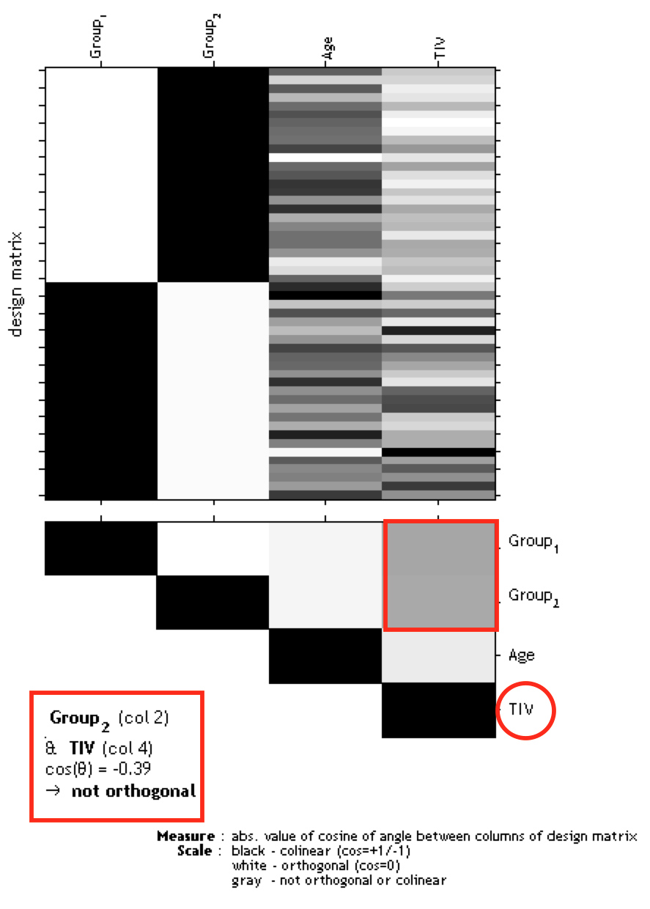
Figure 4: Gray boxes between the parameters point to a correlation: the darker the box the larger the correlation (which also holds for inverse correlations). If you click in the box the colinearity between the parameters will be displayed.

In the case of a considerable correlation an alternative approach is to use global scaling with TIV. Apply the following settings for this approach:
  - Global Calculation → User → Global Values <-X → Define here the TIV values
  - Global Normalisation → Overall grand mean scaling → Yes → Grand mean scaled value → Define here the mean TIV of your sample or (or as approximation a value of 1500 which might fit for the majority of data from adults)
  - Normalization → Proportional

Please note that the global normalization will also affect the absolute threshold for the masking because your images will be now scaled to the “Grand mean scaled value” from the Global Normalisation option. If you have defined here the mean TIV of your sample (or as approximation a value of 1500) no change of the absolute threshold is needed. Otherwise, you have to correct the absolute threshold because your values are now globally scaled to the “Grand mean scaled value” from the Global Normalisation option.

Defining Contrasts

SPM menu → Results → [select the SPM.mat file] → Done (this opens the Contrast Manager) → Define new contrast (i.e., choose “t-contrast” or “F-contrast”; type the contrast name and specify the contrast by typing the respective numbers, as shown below):

Please not that all zeros at the end of the contrast don’t have to be defined, but are kept sometimes for didactic purposes.

Contrasts:
Two-sample T-test | 
T-test  - For Group A > Group B  - For Group A < Group B: | 1 -1  -1 1
F-test  - For any differences between Group A and B: | 1 -1

2x2 ANOVA | 
T-test  - For left-handed males > right-handed males:  - For left-handed females > right-handed females:  - For left-handed males > left-handed females:  - For right-handed males > right-handed females:  - For males > females (main effect sex):  - For left-handers > right-handers (main effect handedness):  - For left-handers > right-handers & males > females:  - For left-handers > right-handers & males < females: | 1 -1 0 0  0 0 1 -1  1 0 -1 0  0 1 0 -1  1 1 -1 -1  1 -1 1 -1  1 -1 -1 1  -1 1 1 -1
F-test  - For main effect handedness in males:  - For main effect handedness in females:  - For main effect sex in left-handers:  - For main effect sex in right-handers:  - For main effect sex:  - For main effect handedness:  - For interaction sex by handedness: | 1 -1 0 0  0 0 1 -1  1 0 -1 0  0 1 0 -1  1 1 -1 -1  1 -1 1 -1  1 -1 -1 1

Multiple Regression (Linear) | 
T-test  - For positive correlation:  - For negative correlation: | 0 0 1  0 0 -1
F-test  - Any correlation: | 0 0 1

The two leading zeros in the contrast are indicating the constant (sample effect, 1st column in the design matrix) and TIV (2nd column in the design matrix). In case that no additional covariate such as TIV is defined you have to skip one of the leading zeros (e.g. “0 1”).

Multiple Regression (Polynomial) | 
T-test  - For positive linear effect:  - For positive quadratic effect:  - For negative linear effect:  - For negative quadratic effect: | 0 0 1 0  0 0 0 1  0 0 -1 0  0 0 0 -1
F-test  - For any linear effect:  - For any quadratic effect:  - For any linear or quadratic effect: | 0 0 1 0  0 0 0 1  0 0 1 0  0 0 0 1

The two leading zeros in the contrast are indicating the constant (sample effect, 1st column in the design matrix) and TIV (2nd column in the design matrix). In case that no additional covariate such as TIV is defined you have to skip one of the leading zeros (e.g. “0 1”).

Interaction (Linear) | 
T-test  - For regression slope Group A > Group B:  - For regression slope Group A < Group B: | 0 0 1 -1 0  0 0 -1 1 0
F-test  - For any difference in regression slope: | 0 0 1 -1 0

The two leading zeros in the contrast are indicating the main effect “group”.

Interaction (Polynomial)

T-test  - For linear regression slope Group A > Group B:  - For linear regression slope Group A < Group B:  - For quadratic regression Group A > Group B:  - For quadratic regression Group A < Group B: | 0 0 1 -1 0 0  0 0 -1 1 0 0  0 0 0 0 1 -1  0 0 0 0 -1 1
F-test  - For any difference in linear regression slope:  - For any difference in quadratic regression:  - For any difference in regression: | 0 0 1 -1 0 0  0 0 0 0 1 -1  0 0 1 -1 0 0  0 0 0 0 1 -1

The two leading zeros in the contrast are indicating the main effect “group”.

F-contrasts (effects of interest):

If you would like to use the old SPM2 F-contrast “Effects of interest” the respective contrast vector is:

eye(n)-1/n

where n is the number of columns of interest.

For interaction and regression effects you have to add leading zeros for the constant term or the sample effects:

[zeros(n,m) eye(n)-1/n]

where m is the number of columns of no interest.

This F-contrast is helpful for checking whether there are any effects in your model (covariates of interest) and is required for plotting parameter estimates of effects of interest.

Getting Results:
SPM menu → Results → [select a contrast from Contrast Manager] → Done
        - Mask with other contrasts → No
        - Title for comparison: [use the pre-defined name from the Contrast Manager or change it]
        - P value adjustment to:
  - None (uncorrected for multiple comparisons), set threshold to 0.001
  - FDR (false discovery rate), set threshold to 0.05, etc.
  - FWE (family-wise error), set threshold to 0.05, etc.
        - Extent threshold: (either use “none” or specify the number of voxels)

Special Cases

CAT12 for longitudinal data

Background
The majority of VBM studies are based on cross-sectional data, where one image is acquired for each subject. However, in order to track e.g. learning effects over time longitudinal designs are necessary, where additional time-points are acquired for each subject. The analysis of these longitudinal data requires a customized processing, that considers the characteristics of intra-subject analysis. While for cross-sectional data images can be processed independently for each subject longitudinal data has to be registered to the baseline image (or mean image) for each subject. Furthermore, spatial normalization is estimated for the baseline image only and applied to all images (Figure 5). Additional attention is then needed for the setup of the statistical model. The following section will therefore describe data preprocessing and model setup for longitudinal data.

Text and figure in preparation
Fig 4.: Flow diagram for processing longitudinal data with CAT12. This figure demonstrates the steps for processing longitudinal data. After an initial realignment, the mean of the realigned images is calculated (mean) and used as reference image in a subsequent realignment. The realigned images (ri_{x}) are then corrected for signal inhomogeneities with regard to the reference mean image. Spatial normalization parameters are estimated in the next step using the segmentations of the mean image. These normalization parameters are applied to the segmentations of the bias-corrected images (p1mri_{x}). The resulting normalized segmentations (wp1mri_{x}) are finally again realigned.

Preprocessing of longitudinal data - overview
The CAT12 Toolbox supplies a batch for longitudinal study design. Here, for each subject the respective images need to be selected. Intra-subject realignment, bias correction, segmentation, and normalization are calculated automatically. Preprocessed images are written as wp1mr* and wp2mr* for grey and white matter respectively. To define the segmentation and normalization parameters, the defaults in cat_defaults.m are used.

Change Settings for Preprocessing

You can change the tissue probability map (TPM) using the GUI or by changing the entry in the file cat_defaults.m. Any parameters that cannot be changed using the GUI have to be set in the file cat_defaults.m:
Change your working directory to “/toolbox/CAT12” in your SPM directory:
→ select “Utilities → cd” in the SPM menu and change to the respective folder.
Then type “open cat_defaults.m” in your matlab command window. The file will open in the editor. If you are unsure how to change the values, open the module “Segment Data” in the batch editor for reference.

Preprocessing of Longitudinal Data

CAT12 → Segment longitudinal data

Parameters:
  - Data <-X → New: Subject →Subject →Longitudinal data for one subject →Select Files → [select raw data] → Done
    - Select all volumes for each subject. As the Toolbox does not support multispectral data yet (i.e., different imaging methods for the same brain, such as T1-, T2-, diffusion-weighted or CT images), it is recommended to choose a T1-weighted image.
    - Select “New: Subject” to add data for a new subject
The data for each subject should be listed as one “subject” in the Batch Editor, i.e. there are as many subjects listed as included in the analysis.
→ For all other options you can follow the instructions for preprocessing of cross-sectional data as described before. Please note that not all writing options are available for longitudinal data.

For the naming conventions of all written files see “Naming convention of output files”. The final GM segments are mwp1r*, the final WM segments are named mwp2r* if you have selected to option to modulate the data. Without modulation the leading “m” is omitted.

Statistical analysis of longitudinal data - overview

The main interest in longitudinal studies is the common change of tissue volume over time in a group of subjects or the difference in these changes between two or more groups. The setup of the statistical model needed to assess these questions will be described on two examples. First, the case of only one group of 4 subjects with 2 time points each (e.g. normal aging) is presented. Subsequently, the case of two groups of subjects with 4 time points per subject will be described. These examples should cover most analyses – the number of time points / groups just have to be adapted. In contrast to the analysis of cross-sectional data as described before we have to use the flexible factorial model that considers that the time points for each subject are dependent data.

Statistical Analysis of Longitudinal Data in One Group

CAT12 → Statistical Analysis → Basic Models

Parameters:
  - Directory <-X → Select Files → [select the working directory for your analysis] → Done
  - Design → “Flexible Factorial”
*SPM is internally handling some keyword factors such as “subject” or “repl”. If you use “subject” as keyword for the first factor the conditions can be easier defined by only labeling the time points as input (see below).
    - Factors → “New: Factor; New: Factor”
Factor
- Name → [specify text (e.g., ”subject”)*]
- Independence → Yes
- Variance → Equal or Unequal
- Grand mean scaling → No
- ANCOVA → No
Factor
- Name → [specify text (e.g., “time”)]
- Independence → No
- Variance → Equal or Unequal
- Grand mean scaling → No
- ANCOVA → No
    - Specify Subjects or all Scans & Factors → “Subjects” → “New: Subject; New: Subject; New: Subject; New: Subject;”
Subject
- Scans → [select files (the smoothed GM volumes of the first Subject)]
- Conditions → “1 2” [for two time points]
Subject
    - Scans → [select files (the smoothed GM volumes of the second Subject)]
    - Conditions → “1 2” [for two time points]
Subject
- Scans → [select files (the smoothed GM volumes of the third Subject)]
- Conditions → “1 2” [for two time points]
Subject
    - Scans → [select files (the smoothed GM volumes of the fourth Subject)]
    - Conditions → “1 2” [for two time points]
    - Main effects & Interaction → “New: Main effect”
Main effect
- Factor number → 2
Main effect
- Factor number → 1
  - Covariates* (see text box in example for two-sample T-test)
  - Masking
    - Threshold Masking → Absolute → [specify value (e.g., “0.1”)]
    - Implicit Mask → Yes
    - Explicit Mask → <None>
  - Global Calculation → Omit
  - Global Normalization
    - Overall grand mean scaling → No
  - Normalization → None

Statistical Analysis of Longitudinal Data in Two Groups

CAT12 → Statistical Analysis → Basic Models

Parameters:
  - Directory <-X → Select Files → [select the working directory for your analysis] → Done
  - Design → “Flexible Factorial”
*SPM is internally handling some keyword factors such as “subject” or “repl”. If you use “subject” as keyword for the first factor the conditions can be easier defined by only labeling the time points as input (see below).
    - Factors → “New: Factor; New: Factor; New: Factor”
Factor
- Name → [specify text (e.g., ”subject”)*]
- Independence → Yes
- Variance → Equal
- Grand mean scaling → No
- ANCOVA → No
Factor
- Name → [specify text (e.g., ”group”)]
- Independence → Yes
- Variance → Unequal
- Grand mean scaling → No
- ANCOVA → No
Factor
- Name → [specify text (e.g., “time”)]
- Independence → No
- Variance → Equal
- Grand mean scaling → No
- ANCOVA → No
    - Specify Subjects or all Scans & Factors → “Subjects” → “New: Subject; New: Subject; New: Subject; New: Subject;”
Subject
- Scans → [select files (the smoothed GM volumes of the 1st Subject of first group)]
- Conditions → “ [1 1 1 1; 1 2 3 4]’ “ [first group with four time points]
Do not forget the additional single quote! Otherwise you have to define the conditions as “ [1 1; 1 2; 1 3; 1 4] “
Subject
- Scans → [select files (the smoothed GM volumes of the 2nd Subject of first group)]
- Conditions → “ [1 1 1 1; 1 2 3 4]’ “ [first group with four time points]
Subject
- Scans → [select files (the smoothed GM volumes of the 3rd Subject of first group)]
- Conditions → “ [1 1 1 1; 1 2 3 4]’ “ [first group with four time points]
Subject
- Scans → [select files (the smoothed GM volumes of the 4th Subject of second group)]
- Conditions → “ [2 2 2 2; 1 2 3 4]’ “ [second group with four time points]
Subject
- Scans → [select files (the smoothed GM volumes of the 1st Subject of second group)]
- Conditions → “ [2 2 2 2; 1 2 3 4]’ “ [second group with four time points]
Subject
- Scans → [select files (the smoothed GM volumes of the 2nd Subject of second group)]
- Conditions → “ [2 2 2 2; 1 2 3 4]’ “ [second group with four time points]
Subject
- Scans → [select files (the smoothed GM volumes of the 3rd Subject of second group)
- Conditions → “ [2 2 2 2; 1 2 3 4]’ ” [second group with four time points]
Subject
- Scans → [select files (the smoothed GM volumes of the 4th Subject of second group)]
- Conditions → “ [2 2 2 2; 1 2 3 4]’ ” [second group with four time points]
    - Main effects & Interaction → “New: Interaction; New: Main effect”
Interaction
- Factor numbers → 2 3 [Interaction between group and time]
Main effect
- Factor number → 1
  - Covariates* (see text box in example for two-sample T-test)
  - Masking
    - Threshold Masking → Absolute → [specify value (e.g., “0.1”)]
    - Implicit Mask → Yes
    - Explicit Mask → <None>
  - Global Calculation → Omit
  - Global Normalization
    - Overall grand mean scaling → No
  - Normalization → None

Contrasts

Longitudinal data in one group (example for two time points) | 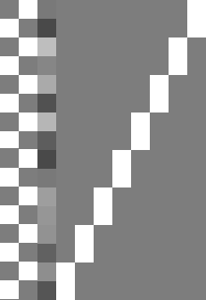
T-test  - For Time 1 > Time 2:  - For Time 1 < Time 2: | 1 -1  -1 1
F-test  - For any differences in Time: | 1 -1

Longitudinal data in two groups (example for two time points) | 
T-test  - For Time 1 > Time 2 in Group A:  - For Time 1 > Time 2 in Group B:  - For Time 1 > Time 2 in both Groups:  - For Time 1 > Time 2 & Group A > Group B: | 1 -1 0 0  0 0 -1 1  1 -1 1 -1  1 -1 -1 1
F-test  - For any differences in Time in Group A:  - For any differences in Time in Group B:  - For Main effect Time:  - For Main effect Group:  - For Interaction Time by Group: | 1 -1 0 0  0 0 1 -1  1 -1 1 -1  ones(1,n)/n -ones(1,n)/n 0 ones(1,n1)/n1 -ones(1,n2)/n2  1 -1 -1 1

Here n1 and n2 are the number of subjects in Group A and B respectively and n is the number of time points. Please note that the zero in the 5th column for the main effect Group indicates the covariate of no interest (e.g. TIV).

Altered Workflows for VBM-analyses
Background
For most analyses the VBM Toolbox will supply all tools needed. That is, as the new segmentation algorithm is not dependent on Tissue Probability Maps (TPMs) anymore and as predefined DARTEL-templates for healthy adults exist, most questions can be assessed using the toolbox settings. However, for some special cases such as analyses in children or special patient populations, the toolbox settings might not be optimal. For these cases the CAT12 Toolbox provides an integration into the SPM12 environment that can be used to optimize the preprocessing. In the following, we will present strategies how to deal with these special cases.

Standard VBM preprocessing: Input, Output and where to modify

The first module of the CAT12 Toolbox (“Segment Data”) processes all preprocessing steps except for the smoothing. Basically, it takes structural volumes and TPMs as input. It will then segment the data, apply a registration to MNI Space (either rigid or affine) and subsequently a non-linear deformation. The non-linear deformation parameters can be calculated via the low dimensional SPM default approach or the high dimensional DARTEL algorithm and the predefined templates. Figure 5 depicts this preprocessing workflow and highlights possibilities where to modify.

Figure in preparation
Fig. 5: Flow-chart of the preprocessing steps within the module “Segment Data”. Marked in red are those steps, where the preprocessing can be customized. Per default, the built-in DARTEL normalization works with the CAT12 DARTEL templates of 550 healthy adult control subjects. Affine registered tissue segments can be used to create customized DARTEL-templates, which can then be used to replace the default DARTEL template.

Adapting the workflows

Customized tissue probability maps - overview
For data on children it will be a good idea to create customized TPMs, which reflect age and gender of the population. The TOM8 Toolbox (available via: https://irc.cchmc.org/software/tom.php) provides the means to customize these TPMs. To learn more about the TOM toolbox, see also http://dbm.neuro.uni-jena.de/software/tom/.

Customized Tissue Probability Maps

About the TOM8 Toolbox:
→ select Module “create new template”
→ select “TOM.mat” (you will have to download this file together with the toolbox)
→ write priors/template as single file
→ for all others use default settings or modify. For “Age” either a vector or a mean age (when using the average approach) must be specified.
Implementation into CAT12:
CAT12 → Segment Data

Parameters:
  - Options for initial SPM12 affine registration
    - Tissue Probability Map (→ Select your customized TPMs here)

Customized DARTEL-template - overview
For all cases that include at least 50-100 subjects a customized DARTEL template can be created. That is, grey matter and white matter tissue segments of all subjects are used to create a mean template of the study sample. As the CAT12 toolbox writes all files needed to create these templates (“DARTEL export”), this requires only two additional steps. In order to use these newly created DARTEL-Templates with the CAT12 Toolbox, an affine registration of the DARTEL export should be used. From these affine registered segments customized DARTEL templates can then be created and used with the CAT12 module “Segment Data”.

Customized DARTEL-template

Please note that the use of an own DARTEL template will result in deviations and unreliable results for any ROI-based estimations because the atlases will differ.
Several steps are needed to create normalized tissue segments with customized DARTEL Templates. These steps can be batched using dependencies in the Batch Editor. The last step can be rerun using the customized templates, if additional output files are needed. In the first step the T1 images are segmented, and the tissue segments normalized to the Tissue Probability Maps using an affine transformation. Start with selecting the module “Segment Data”.

CAT12 → Segment Data

Parameters:
→ for all options except “writing options” use settings like for a “standard” VBM analysis.
  - Writing Options
- “Grey Matter”→ “Modulated normalized” → “No”
- “Grey Matter”→ “DARTEL export” → “affine”
- “White Matter”→ “Modulated normalized” → “No”
- “White Matter”→ “DARTEL export” → “affine”

These settings will produce the volumes “rp1*-affine.nii” and “rp2*-affine.nii”, which are the grey (rp1) and white (rp2) matter segments after affine registration. The following modules can be chosen directly in the batch editor (SPM → Tools → DARTEL Tools → Run DARTEL (create Templates), and SPM → Tools → CAT12 → CAT12: Segment Data). It makes sense to add and specify these modules together with the “Segment Data” module within the Batch Editor and to set dependencies.

SPM → Tools → Dartel Tools → Run DARTEL (create Templates)

Parameters:
Images → select two times “new: Images”
    - Images: → select the “rp1*-affine.nii” files or create a dependency.
    - Images: → select the “rp2*-affine.nii” files or create a dependency.
→ all other options: use defaults or modify

SPM → Tools → Dartel Tools → Normalise to MNI space

Parameters:
Dartel Template → select the final created template with the ending “_6”.
  - Select according to → “Many Subjects”
    - Flow fields: → select the “u_*.nii” files or create a dependency.
- Images: → New: Images → select the “rp1*-affine.nii” files or create a dependency.
- Images: → New: Images → select the “rp2*-affine.nii” files or create a dependency.
  - Preserve: → “Preserve Amount”
  - Gaussian FWHM: → use defaults or modify
→ all other options: use defaults or modify
Please note, that a subsequent smoothing is not necessary before statistics if you have used the option “Normalise to MNI space” with a defined Gaussian FWHM.

Re-use of customized DARTEL-templates
Optionally you can also use the new created customized DARTEL templates in the CAT12 Toolbox. This might be helpful if new data are close (in terms of age) to the data that have been used for creating the DARTEL template. Then, it is not mandatory to always create a new template and you can simply use the previously created DARTEL template. In that case an additional registration to MNI (ICBM) space has to be applied:

SPM → Tools → Dartel Tools → Run DARTEL (Population to ICBM Registration)

Parameters:
Dartel Template → select the final created template with the ending “_6”.

SPM → Util → Deformations

Parameters:
Composition → “New: Deformation Field”
    - Deformation Field: → select the “y_*2mni.nii” file from step above.
  - Output → “New: Pushforward”
    - Apply to → select all “Template” files with the ending “_0” to “_6”.
    - Output destination → Output directory → select directory for saving files.
    - Field of View → Image Defined → select final “Template” file with the ending “_6”.
    - Preserve → Preserve Concentrations (no “modulation”).

Finally, the new template can be used as default DARTEL template for any new data that are close to the data that have been used for template creation:
CAT12 → Segment Data

Parameters:
  - Volumes <-X → Select the original T1 images like in the first module “Segment Data”.
  - Extended Options for CAT12 segmentation → “Spatial normalization Template” → Select normalized DARTEL Template “wTemplate*_1.nii”
    - For all other options use the same settings as in the first module, or modify.
  - Writing Options → select the output files just like in any standard VBM analysis:

How to proceed
All steps described above are just an adaption of the CAT12 Toolbox module “Segment Data”. As always it is a good idea to save the applied modules and to perform quality control. Here, the modules “Display one slice for all images” and “Check sample homogeneity” from the CAT12 Toolbox will be helpful. Please also note that the use of

Other variants of computational morphometry

Deformation-based morphometry (DBM)
Background

DBM is based on the application of non-linear registration procedures to spatially normalise one brain to another one. The simplest case of spatial normalisation is to correct the orientation and size of the brains. In addition to these global changes, a non-linear normalisation is necessary to minimise the remaining regional differences by means of local deformations. If this local adaptation is possible, the deformations now reveal information about the type and localization of the structural differences between the brains and can undergo subsequent analysis.

Differences between both images are minimized and are now coded in the deformations. Finally, a map of local volume changes can be quantified by a mathematical property of these deformations – the Jacobian determinant. This parameter is well known from continuum mechanics and is usually used for the analysis of volume changes in flowing liquids or gases. The Jacobian determinant allows a direct estimation of the percentage change in volume in each voxel and can be statistically analyzed . This approach is also known as tensor-based morphometry because the Jacobian determinant represents such a tensor.

A deformation-based analysis can be carried out not only on the local changes in volume but also on the entire information of the deformations, which also includes the direction and strength of the local deformations . Since each voxel contains three-dimensional information, a multivariate statistical test is necessary for analysis. A multivariate general linear model or Hotelling’s T2 test is commonly used for this type of analysis .

Additional Steps in CAT12

CAT12 → Segment Data

Parameters:
  - Writing options → Jacobian determinant → Normalized → Yes
    - In order to save the estimated volume changes change the writing option for the normalized Jacobian determinant to “yes”.

Changes in statistical analysis
Follow the steps for the statistical analysis as described for VBM, select the smoothed Jacobian determinants (e.g. swj_*.nii ) and change the following parameters:

CAT12 → Statistical Analysis → Basic Models

Parameters:
  - Covariates: Don’t use TIV as covariate
  - Masking
    - Threshold Masking → None
    - Implicit Mask → Yes
    - Explicit Mask → ../spm12/tpm/mask_ICV.nii

Surface-based morphometry (SBM)
Background
Surface-based morphometry has several advantages over using volumetric data alone. For instance, brain surface meshes have been shown to increase the accuracy of brain registration compared with Talairach registration (Desai et al. 2005). Brain surface meshes also permit new forms of analyses, such as gyrification indices that measure surface complexity in 3D (Yotter et al. 2011b) or cortical thickness (Gaser et al. 2016). Furthermore, inflation or spherical mapping of the cortical surface mesh raises the buried sulci to the surface so that mapped functional activity in these regions can be easily visualized.

Local adaptive segmentation
Gray matter regions with high iron concentration, like the motor cortex and the occipital regions, often have increased intensities that lead to misclassications. In addition to our adaptive MAP approach for partial volume segmentation we use an approach that allows adaptation of local intensity changes in order to deal with varying tissue contrast (Dahnke et al. 2012a).

Cortical thickness and central surface estimation
We use a fully automated method that allows for measurement of cortical thickness and reconstructions of the central surface in one step. It uses a tissue segmentation to estimate the white matter (WM) distance, then projects the local maxima (which is equal to the cortical thickness) to other gray matter voxels by using a neighbor relationship described by the WM distance. This projection-based thickness (PBT) allows the handling of partial volume information, sulcal blurring, and sulcal asymmetries without explicit sulcus reconstruction (Dahnke et al. 2012b).

Topological correction
In order to repair topological defects we use a novel method that relies on spherical harmonics (Yotter et al. 2011a). First, the original MRI intensity values are used as a basis to select either a “ﬁll” or “cut” operation for each topological defect. We modify the spherical map of the uncorrected brain surface mesh, such that certain triangles are favored while searching for the bounding triangle during reparameterization. Then, a low-pass filtered alternative reconstruction based on spherical harmonics is patched into the reconstructed surface in areas that previously contained defects.

Spherical mapping
A spherical map of a cortical surface is usually necessary to reparameterize the surface mesh into a common coordinate system to allow inter-subject analysis. We use a fast algorithm to reduce area distortion resulting in an improved reparameterization of the cortical surface mesh (Yotter et al. 2011c).

Spherical registration
We have adapted the volume-based diffeomorphic Dartel algorithm to the surface (Ashburner, 2007) to work with spherical maps (Yotter et al. 2011d). We apply a multi-grid approach that uses reparameterized values of sulcal depth and shape index defined on the sphere to estimate a flow field that allows deforming a spherical grid.

Additional Steps in CAT12

CAT12 → Segment Data

Parameters:
  - Writing options → Surface and thickness estimation → Yes
Use projection-based thickness to estimate cortical thickness and to create the central cortical surface for the left and right hemisphere.

CAT12 → Surface Tools → Resample & Smooth Surfaces

Parameters:
  - Surface Data <-X → Select the surface data (e.g. [lr]h.thickness.*)
  - Smoothing Filter Size in FWHM [use defaults or modify]
    - 12-18mm kernels are widely used for SBM and I recommend to start with a value of 15mm.
  - Split job into separate processes
    - In order to use multi-threading the CAT12 segmentation job with multiple subjects can be split into separate processes that run in the background. You can even close Matlab, which will not affect the processes that will run in the background without GUI. If you don not want to run processes in the background then set this value to 0.
    - Keep in mind that each process needs about 1.5..2GB of RAM, which should be considered to choose the right number of processes.
    - Please further note that no additional modules in the batch can be run except CAT12 segmentation. Any dependencies will be broken for subsequent modules.

Extract optional surface parameters
You can also extract additional surface parameters that have to be resampled and smoothed with the before mentioned tool.

CAT12 → Surface Tools → Extract & Map Surface Data → Extract Additional Surface Parameters

Parameters:
  - Central Surfaces <-X → Select the central surface data (e.g. [lr]h.central.*)
  - Gyrification index
    - Extract gyrification index (GI) based on absolute mean curvature. The method is described in Luders et al. NeuroImage, 29: 1224-1230, 2006.
  - Cortical complexity (fractal dimension)
Extract Cortical complexity (fractal dimension) which is described in Yotter et al. Neuroimage, 56(3): 961-973, 2011.
Warning: Estimation of cortical complexity is very slow!
  - Sulcus depth
Extract sqrt-transformed sulcus depth based on the euclidean distance between the central surface and its convex hull.
Transformation with sqrt-function is used to render the data more normally distributed.

Changes in statistical analysis
For statistical analysis of surface measures you can use the common 2nd level models that are also used for VBM. However, you have to analyze each hemisphere (indicated by “lh” and “rh”) separately. Follow the steps for the statistical analysis as described for VBM and change the following parameters:

CAT12 → Statistical Analysis → Basic Models

Parameters:
  - Covariates: Don’t use TIV as covariate
  - Masking
    - Threshold Masking → None
    - Implicit Mask → Yes
    - Explicit Mask → <none>

As input you have to select the resampled and smoothed files (see above). A thickness file of the left hemisphere that was resampled and smoothed with the default FWHM of 15mm is named as:

S15mm.lh.thickness.resampled.name.gii

where “name” if the original filename without extension. Please note that these files are saved in the surf-folder as default.

Do not use the “Estimate” function in the SPM window, but rather use the respective function in CAT12. This allows to overlay your results automatically onto the Freesurfer average surface:

CAT12 → Statistical Analysis → Estimate Surface Models

Region of interest (ROI) analysis

CAT12 allows estimation of tissue volumes (and additional surface parameters such as cortical thickness) for different volume and surface-based atlas maps (Gaser et al. 2016). All of these results are estimated in native space before any spatial normalization. The results for each dataset are stored as XML files in the label directory. The XML file catROI[s]_*.xml contains information of all atlases as data structure for one dataset and the optional “s” indicates surface atlases. You can use the CAT function “cat_io_xml” to read the XML data as structure.

Please note that in the beta version of CAT12 these XML files were not automatically saved because the option for ROI analysis was disabled. If the option "cat12.output.ROI" in cat_defaults.m is set to "0" no ROI XML files are saved and you have to set this parameter to "1" and preprocess the data again if you are interested in ROI analysis of volume data (for surface data these XML files are always extracted after preprocessing, thus it is not necessary to do this for surface data).

Additional steps for surface data

While ROI-based values for VBM (volume) data are automatically saved in the label folder as XML file it is necessary to additionally extract these values for surface data. This has to be done after preprocessing the data and creating cortical surfaces. You can extract ROI-based values for cortical thickness but also for any other surface parameter that was extracted using the “Extract Additional Surface Parameters” function:
CAT12 → Extract ROI Data → Extract ROI-based surface values

Parameters:
  - (Left) Surface Data Files <-X → Select surface data files such as lh.thickness.* for all subjects

Statistical analysis of ROI data

Finally, the XML files of several subjects can be analyzed using an already existing SPM design with CAT12 → Analyze ROIs. Here, the SPM.mat file is used in order to get information about all respective label files, but also about your design (including all covariates/confounds you have modeled). Thus, the same statistical analysis that is saved in the SPM.mat file is applied to your ROI data. You can then select a contrast, a threshold and a measures to analyze (e.g. Vgm, Vwm, thickness, gyrification...) and can choose between different atlas maps. The results will be printed and saved as thresholded log-p volume or surface map:

logPThreshold_NameOfContrast_NameOfAtlas_Measure.nii

[lr]h.logPThreshold_NameOfContrast_NameOfAtlas_Measure.gii

These maps can be optionally visualized using CAT12 → Display Results → Slice Overlay for volume maps or CAT12 → Display Results → Display surface results for surface maps.

In order to analyze different measures (e.g. Vgm/Vwm for volumes or thickness/gyrification for surfaces) you can use any existing volume-based analysis to extract different volume measures or any existing surface-based analysis to extract different surface measures. To give an example: An existing SPM.mat file with a VBM analysis of GM allows you to analyze ROI measures for both, GM as well as WM. Thus, it is not necessary to have a SPM.mat file of a VBM analysis of WM. The same holds for surface-based analysis. If you have an existing SPM.mat for the analysis of cortical thickness you can also estimate ROI analysis for gyrification or fractal dimension. However, it is necessary to extract before ROI-based measures for each subject using CAT12 → Extract ROI Data → Extract ROI-based surface values.

For ROI analysis of surfaces you can select the SPM.mat file of the analysis either for the left or right hemisphere. The design should be the same and the ROI results will be always estimated for both hemispheres.

Please note, that if you have moved your data after estimating your original voxel- or surfaced-based statistics the needed ROI files cannot be found.

Optional extraction of ROI data

Finally, the XML files of several subjects can be combined and saved for further analysis as CSV file using the “Estimate Mean Values inside ROI” function:
CAT12 → Extract ROI Data → Estimate mean values inside ROI

Parameters:
  - XML files <-X → Select xml files for each subject that are saved in the label folder.
  - Output file → Define output name for csv file. This name is extended by the atlas name and the name of the measure (e.g. “Vgm” for gray matter volume)

For each measure (e.g. “Vgm” for gray matter volume) and each atlas a separate CSV file is written. This works for both volume as well as surface data, but volume and surface data has to be processed separately using this function (surface-based ROI values are indicated by an additional “s”, e.g. ''catROIs_''). You can use external software such as Excel or SPSS to read the resulting CSV files for further analysis. Take also care of the different interpretation between “.” and “,” depending on your region and language settings on your system.

Use of atlas functions in SPM12

Moreover, you can use the volume-based atlases that are provided with CAT also as atlas maps with SPM atlas functions. This is especially helpful if you have used the default VBM processing pipeline because the CAT12 atlas maps are then in the same DARTEL space as your data. Thus, if you have used the default VBM processing pipeline it is recommended to use the CAT12 atlases in DARTEL space rather than the SPM Neuromorphometrics atlas. In order to use CAT12 atlases you have to call the cat_install_atlases function once that will copy the atlases to SPM. By default only Neuromorphometics, LPBA40, and Hammers atlas maps are used and are indicated in the name by a leading ''dartel_''.

Atlas maps for surfaces can be used with the function CAT12 → Display Results → Display Surface Results. Here, the data cursor function allows you to display atlas regions under the cursor. Furthermore, you can use the ''Atlas labeling'' function to print a list of atlas regions of the resulting clusters.

Additional information on native, normalized and modulated volumes

When preprocessing the images (see “First Module: Segment Data”, on pages 5-6), the decision about the normalization parameters will determine the interpretation of the analysis outcomes. Please note that some of the output options are only available in the expert mode.

“Native space” produces tissue class images in spatial correspondence to the original data. Although this could be useful for estimating global tissue volumes (e.g., GM+WM+CSF=TIV) it is not suitable to conduct VBM analyses due to the missing voxel-wise correspondence across brains). Of note, if one is interested in these global tissue volumes in native space (“raw values”), it won’t be necessary to actually output the tissue class images in native space. The “Segment Data”-function automatically generates an xml file for each subject (cat_*.xml), which contains the raw values for GM, WM, and CSF. The subject-specific values can be combined (i.e., integrated into a single text file) by using the function: CAT12 → Statistical Analysis → Estimate TIV.

“Normalized” produces tissue class images in spatial correspondence to the template. This is useful for VBM analyses (e.g., “concentration” of gray matter; Good et al. 2001; Neuroimage).

“Modulated normalized” produces tissue class images in alignment with the template, but multiplies (“modulates”) the voxel values by the Jacobian determinant (i.e., linear and non-linear components) derived from the spatial normalization. This is useful for VBM analyses and allows comparing the absolute amount of tissue (e.g., “volume” of gray matter; Good et al. 2001; Neuroimage). Please note that by using this type of modulation you have to use TIV as covariate in order to correct for different brain sizes. An alternative approach is to use global scaling with TIV if TIV is correlating too much with your covariates of interest. See the section about “Checking for Design Orthogonality” for more information.
If you use the expert mode you can optionally choose to modulate your data for non-linear terms only, which was the default for previous VBM versions. This produces tissue class images in alignment with the template, but multiplies the voxel values by the non-linear components only. This is useful for VBM analyses and allows comparing the absolute amount of tissue corrected for individual brain sizes. Of note, this option is similar to using “Affine+non-linear” (see above) in combination with “global normalization” (when later building the statistical model using the traditional PET designs). Although this type of modulation was used in previous VBM versions as default it is not recommended anymore because the use of the standard modulation in combination with TIV as covariate gives more reliable results (Malone et al. 2015; Neuroimage).

Naming convention of output files

Please note that the resulting files of CAT12 are organized in separate subfolders (e.g. mri, report, surf, label). If you don't want to use subfolders you can change the option "cat12.extopts.subfolders" in cat_default.m to "0".

Images (saved in subfolder "mri")
Segmented Images: | #p[0123]* | [m[0]w]p[0123]*[_affine].nii
Bias, noise and intensity corrected T1 image: | #m* | [w]m*.nii
Jacobian determinant | #j_ | wj_*.nii
Deformation field (inverse field) | y_ (iy_) | y_*.nii (iy_*.nii)

* | filename
# | image space prefix
Image space prefix:
m | modulated
m0 | modulated non-linear only (expert mode only)
w | warped (spatially normalized using DARTEL)
Image space extension:
_affine | affine registered only
Image data prefix:
p | partial volume (PV) segmentation
0 | PV label
1 | GM
2 | WM
3 | CSF

Surfaces in native space (saved in subfolder "surf")
SURF.TYPE.*.gii
SURF | left, right hemisphere [ lh | rh ]
TYPE | surface data file [ central | sphere | thickness | gyrification | ... ]
 | central - coordinates and faces of the central surface
 | sphere - coordinates and faces of the spherical projection of the central surface
 | sphere.reg - coordinates and faces of the sphere after spherical registration
 | thickness - thickness values of the surface
 | sqrtsulc - sqrt-transformed values of sulcul depth based on the euclidian distance between the central surface and its convex hull
 | gyrification - gyrification values based on absolute mean curvature
 | fractaldimension - fractal dimension values (cortical complexity)

Surfaces in (normalized) template space (after resampling and smoothing; saved in subfolder "surf")
FWHM.SURF.TYPE.resampled.*.gii
FWHM | filtersize in FWHM after smoothing (e.g. s15mm)
SURF | left, right hemisphere [ lh | rh ]
TYPE | surface data file [ thickness | gyrification | fractaldimension | ... ]
 | thickness - thickness values of the surface
 | sqrtsulc - sqrt-transformed values of sulcul depth based on the euclidian distance between the central surface and its convex hull
 | gyrification - gyrification values based on absolute mean curvature
 | fractaldimension - fractal dimension values (cortical complexity)

Images and surface of longitudinal data
After processing longitudinal data the filenames additionally contain an "r" between the original filename and the other prefixes to indicate the additional registration step. Please also note that only the bias, noise and intensity corrected average image of all time points for each subject is saved.

Reports (saved in subfolder "report")
Global morphometric and image quality measures are stored in the cat_*.xml file. This file also contains other useful information about software versions and the used options for preprocessing the data. You can use the cat_io_xml function to read data from xml-files. Furthermore, a report for each data set is saved as pdf-file catreport_*.pdf.

Regions of interest (ROI) data (saved in subfolder "label")
ROI data is optionally saved as xml-file catROI [s]_*.xml. The optional “s” indicates surface atlases.

Calling CAT from the UNIX command line
You can call CAT also from the Unix command line as shell script. This allows to run the process completely in the background without any graphical output and distribute all given data to parallel jobs. This might be helpful if you want to run CAT on a computer cluster.
You can use the shell scripts cat_batch_cat.sh or cat_batch_long.sh (for longitudinal data). Please call the scripts to see more information how to define for example optional defaults files.
Furthermore, there exists a script distribute_to_server.sh to distribute jobs to different servers.

Technical information
This toolbox is an extension of the segmentation in SPM12, but uses a completely different segmentation approach.

AMAP Segmentation
The segmentation approach is based on an Adaptive Maximum A Posterior (AMAP) technique without the need for a priori information about tissue probabilities. That is, the Tissue Probability Maps (TPM) are not used constantly in the sense of the classical Unified Segmentation approach (Ashburner et. al. 2005), but only for spatial normalization and the initial skull-stripping. The following AMAP estimation is adaptive in the sense that local variations of the parameters (i.e., means and variance) are modelled as slowly varying spatial functions (Rajapakse et al. 1997). This not only accounts for intensity inhomogeneities but also for other local variations of intensity.

Partial Volume Segmentation
Additionally, the segmentation approach uses a Partial Volume Estimation (PVE) with a simplified mixed model of at most two tissue types (Tohka et al. 2004). We start with an initial segmentation into three pure classes: gray matter (GM), white matter (WM), and cerebrospinal fluid (CSF) based on the above described AMAP estimation. The initial segmentation is followed by a PVE of two additional mixed classes: GM-WM and GM-CSF. This results in an estimation of the amount (or fraction) of each pure tissue type present in every voxel (as single voxels - given by their size - probably contain more than one tissue type) and thus provides a more accurate segmentation.

Denoising
Furthermore, we apply two denoising methods. The first method is a spatial-adaptive Non-Local Means (SANLM) denoising filter (Manjón et al. 2010) that is applied after the intensity normalization. This filter removes noise while preserving edges and is implemented as preprocessing step. The second method is a classical Markov Random Field (MRF) approach, which incorporates spatial prior information of adjacent voxels into the segmentation estimation (Rajapakse et al. 1997) and is part of the AMAP segmentation. The strength of the filters is automatically obtained by estimating the remaining noise in the image.

Dartel Normalisation
Another important extension to the SPM12 segmentation is the integration of the Dartel normalisation (Ashburner 2007) into the toolbox by an already existing Dartel template in MNI space. This template was derived from 555 healthy control subjects of the IXI-database (http://www.brain-development.org) and is provided in MNI space for six different iteration steps of Dartel normalisation. Thus, for the majority of studies the creation of sample-specific Dartel templates is not necessary anymore.

Local Adaptive Segmentation (LAS)
Beside WM-inhomogeneities, also the GM intensity can vary for different regions like the motor cortex, the basal ganglia, or the occipital lobe. Although, these changes have an anatomical background (e.g. iron content, myelenization), they depend on the MR-protocol and often lead to GM-underestimations for higher intensities and CSF-overestimations for lower intensities. Therefore, a local intensity transformation of all tissue classes is used in order to reduce this effects in the image before the final AMAP segmentation. The strength of the changes is controlled by the LASstr parameter, with 0 for no LAS, small values (0.01-0.5) for small adaptations, 0.5 for average adaptation (default), and higher values (0.5-1) for strong adaptations.

Skull-Stripping
CAT12 contains a revised graph-cut based skull-stripping with a arbitrary strength, with 0 for a more liberal and wider brain masks and 1 for a more aggressive skull-stripping. The default is 0.5 and was successfully tested on a variety of different images.
The strength parameter affects multiple internal parameters:
- Intensity thresholds to deal with blood-vessels and meninges
- Distance and growing parameters for the graph-cut/region-growing
- Closing parameters that fill the sulci
- Smoothing parameters that allow sharper or wider results
If your segmentations still contain skull and other non-brain tissue (e.g. dura) you can try to increase the strength. If parts of the brain are missing in the segmentations the strength can be decreased.

Affine Preprocessing (APP)
To improve the initial SPM segmentation an initial affine registration on a bias-corrected image is applied and the intensity range is limited to avoid problems in special protocols. If preprocessing fails a more aggressive version is available that applies a rough bias correction and removes non-brain parts the brain before the initial affine registration.

Cleanup
CAT12 includes a new cleanup routine that uses morphological, distance and smoothing operations to remove remaining meninges from the final segmentation. The strength of the cleanup is controlled by the cleanupstr parameter, with 0 for no cleanup, low values <0.5 for light cleanup, 0.5 for average cleanup (default), and 1 for strong cleanup.

Interpolation
CAT12 uses an internal interpolation in order to allow more reliable results also for low resolution images and anisotropic spatial resolutions. Although an interpolation cannot add further details to the images, some of the used functions benefit from the higher number of voxels and the common striped artefacts in modulated images are strongly diminished.
References

J. Ashburner (2005): Unified segmentation. Neuroimage 26(3):839-51.
J. Ashburner (2007): A fast diffeomorphic image registration algorithm. Neuroimage 38(1):95-113.
E. Luders, P.M. Thompson, K.L. Narr, A.W. Toga, L. Jancke, C. Gaser (2006): A curvature-based approach to estimate local gyrification on the cortical surface. Neuroimage, 29(4): 1224-30.
C. Gaser, H.-P. Volz, S. Kiebel, S. Riehemann, H. Sauer (1999): Detecting structural changes in whole brain based on nonlinear deformations – application to schizophrenia research. Neuroimage, 10:107-113.
C. Gaser, I. Nenadic, B. Buchsbaum, E. Hazlett, M. S. Buchsbaum (2001): Deformation-based morphometry and its relation to conventional volumetry of brain lateral ventricles in MRI. Neuroimage, 13:1140-1145.
C. Gaser, R. Dahnke (2016). CAT - A Computational Anatomy Toolbox for the Analysis of Structural MRI Data. HBM 2016. http://www.neuro.uni-jena.de/hbm2016/GaserHBM2016.pdf
R. Dahnke, R. Yotter, C. Gaser (2012a). Cortical thickness and central surface estimation. Neuroimage, 65: 336-348.
R. Dahnke, G. Ziegler, C. Gaser (2012b). Local Adaptive Segmentation. HBM 2012. http://www.neuro.uni-jena.de/hbm2012/HBM2012-Dahnke02.pdf
R. Desai, E. Liebenthal, E.T. Possing, E. Waldron, J.R. Binder (2005): Volumetric vs. surface-based alignment for localization of auditory cortex activation. Neuroimage 26(4):1019-29.
C.D. Good, I.S. Johnsrude, J. Ashburner, R.N. Henson, K.J. Friston, R.S. Frackowiak (2001): A voxel-based morphometric study of ageing in 465 normal adult human brains. Neuroimage. 14(1 Pt 1):21-36.
I.B. Malone, K.K. Leung, S. Clegg, J. Barnes, J.L. Whitwell, J. Ashburner, N.C. Fox, G.R. Ridgway (2015): Accurate automatic estimation of total intracranial volume: a nuisance variable with less nuisance. Neuroimage 104:366-72.
J. Manjon, P Coupe, L. Marti-Bonmati, D.L. Collins, M. Robles (2010). Adaptive Non-Local Means Denoising of MR Images With Spatially Varying Noise Levels Journal of Magnetic Resonance Imaging, 31: 192-203.
J.C. Rajapakse, J.N. Giedd, J.L. Rapoport (1997): Statistical Approach to Segmentation of Single-Channel Cerebral MR Images. IEEE Trans. Med. Imag. 16(2):176-186.
J. Tohka, A. Zijdenbos, A. Evans (2004): Fast and robust parameter estimation for statistical partial volume models in brain MRI. Neuroimage 23(1):84-97.
R.A. Yotter, R. Dahnke, P.M. Thompson, C. Gaser (2011a): Topological Correction of Brain Surface Meshes Using Spherical Harmonics. Human Brain Mapping, 32(7): 1109-24.
R.A. Yotter, G. Ziegler, I. Nenadic, P.M. Thompson, C. Gaser (2011b): Local cortical surface complexity maps from spherical harmonic reconstructions. Neuroimage, 56(3): 961-973.
R.A. Yotter, P.M. Thompson, C. Gaser (2011c): Algorithms to Improve the Re-Parameterization of Spherical Mappings of Brain. Journal of Neuroimaging, 21(2):e134-47.
R.A. Yotter, G. Ziegler, P.M. Thompson, C. Gaser (2011d): Diffeometric Anatomical Registration on the Surface. HBM 2011.

7-Nov-26 Christian Gaser christian.gaser@uni-jena.de
Florian Kurth fkurth@loni.ucla.edu

Additional CAT12-related information can be found by selecting “VBM Website“ in the CAT12 window (Tools → Internet → VBM Website”). This will open a website. Here, look for “VBM subpages” on the right.
In order to empirically determine the extent threshold (rather than saying 100 voxels or 500 voxels, which is completely arbitrary), simply run this first without specifying an extent threshold. This will give you an output (i.e., the standard SPM glass brain with significant effects). When you click “Table” (SPM main menu) you will get a table with all relevant values (MNI coordinates, p-values, cluster size etc). Below the table you will find additional information, such as “Expected Number of Voxels per Cluster”. Remember this number (this is your empirically determined extent threshold). Re-run SPM → Results etc. and specify this number when asked for the “Extent Threshold”. There is also a hidden option in “CAT12 → Data presentation → Threshold and transform spmT-maps” to define the extent threshold in terms of a p-value or to use the “Expected Number of Voxels per Cluster”.
The classic SPM12 segmentation is still used in addition, but only to initially remove non-brain tissue from the image and to get a starting estimate for the segmentation.
Thus, no additional MNI normalization is necessary.
For studies investigating data of children I still recommend creating a customized Dartel template. Of note, for this option a representative sample with a sufficient number of subjects is required.

